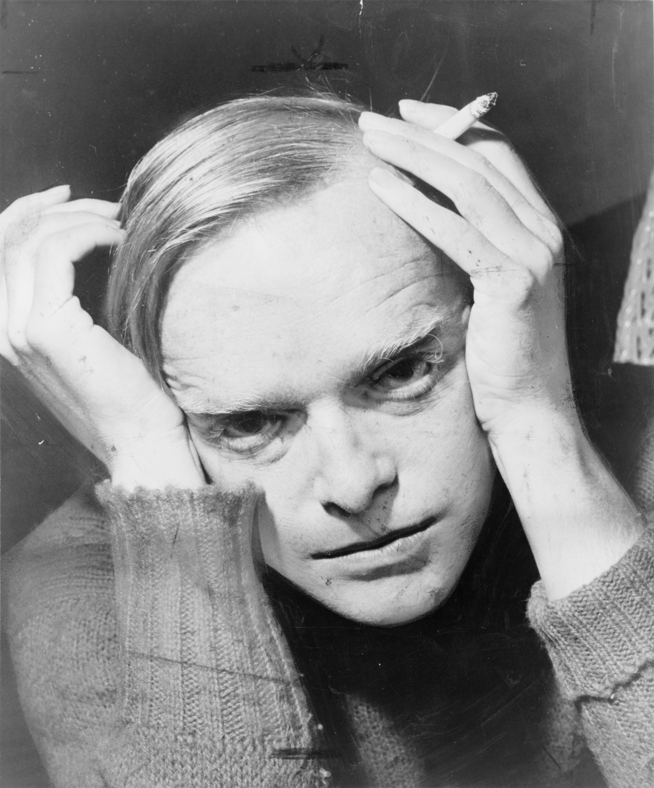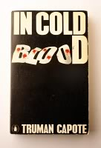

•Capote's captivating narrative delves into the psychological and emotional depths of a senseless quadruple murder

•Capote put Holcomb, Kansas on the map, a town that America would come to know, but a town that few Kansans knew existed before the publication of *In Cold Blood*

•Capote used interview techniques to write the nonfiction novel

•What began as questions and answers became a work of literature

• He wrote what he thought the real people would probably have said and thought. By using these analytical tools he crafted and created characters for his nonfiction novel

# Kathryn Harcum

# English 12

# 2017-2018 School Year

# “Nonfiction fiction” is how Capote described *In Cold Blood*.

# Truman Capote

# 1924-1984

Journalistic

Literature